Red Land Girls Softball – 2026

ALPHABRODER - (www.alphabroder.com) |  |  |  | Color | Size | Cost | Qty
Color: |  | Navy, Red, Royal, White
G500B | Short Sleeve T- Shirt | Youth sizes: Small - XL | $ 16.00
G500 | Short Sleeve T- Shirt | Adult size: Small - 4XL | $ 17.00
G540B | Long Sleeve T-Shirt | Youth sizes: Small -XL | $ 18.00
G540 | Long Sleeve T-Shirt | Adult size: Small - 4XL | $20.00
G180B | Crewneck Sweatshirt | Youth sizes: Small - L | $ 22.00
G180 | Crewneck Sweatshirt | Adult size: Small - 4XL | $ 24.00
G185B | Hooded Sweatshirt | Youth sizes: Small -L | $ 26.00
G185 | Hooded Sweatshirt | Adult size: Small - 3XL | $ 27.00

Augusta Sportswear - (www.augustasportswear.com) |  |  |  | Color | Size | Cost | Qty
Color: |  | N/A
229679 Youth | Navy/Scarlet/White  Jacket that players wear | Youth sizes: Small - XL | $ 45.00
229779  Ladies | Navy/Scarlet/White  Jacket that players wear | Ladies sizes: XS-XL | $ 46.00

9019A | Pullover | Adult size: Small - L | $ 51.00

item # | Item Description | Color | Size | Cost | Qty
CD100Y  CD100A | Tie Dye T-shirts Small thru Large $19.00  Adult Small thru 3XL $20.00  RED / ROYAL / NAVY
CD877Y  CD877 | Tie Dye Hoodie Small thru Large $31.00  ROYAL OR NAVY  Adult Tie Dye Hoodie Small thru 3XL $32.00

• Price includes RLGSA logo
• 2XL and larger - Add $3.00
• Names Opposite Logo - Add $3.00
• Names on back of item - Add $9.00 (lettering is 1” to 11/2” high depending on # of letters in name)
• ADD Wording on backs: Patriots $13.00 or Red Land Softball add $18.00
Name: ________________________________________ Phone #: ___________________________
Email for notification when completed: _______________________________________ Payment Method:
Cash _____ ________ Venmo: @Tracy-Leakway
Visa/MasterCard #___________________________________, Expiration _______

CVV______ ZIP CODE _________________
Portion of sales donated back to RLGSA
Allow 2 weeks for delivery. Payment due when order is placed.

www.haringoriginals.com

POC: Tracy Leakway, 717-648-1707 or haringoriginals@aol.com

Red Land Girls Softball – 2023
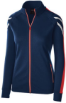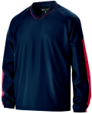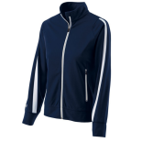
Pullover Adult
Augusta Sportswear (#229019)

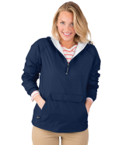Ladies pullover
Charles River Apparel (9905)
Ladies Navy white
Augusta Sportswear
(# 229342)

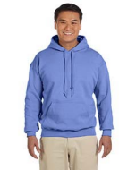Hooded Sweatshirt AlphaBroder (# G185)

Augusta Sportswear
(# 229768)
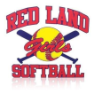
Red Land
Girls Softball logo

